# Content

**1**

**Quiz 1 - Introduction to Big Data 2**

**Quiz 2 - Big Data Process 3**

**Quiz 3 - Types of Data 5**

**Quiz 4 - MongoDB 8**

**Quiz 5 - Hadoop 10**

**Quiz 6 - Hadoop Zoo 11**

**Quiz 7 - Consolidation 13**

**IR Test Quiz - Part 1 14**

**IR Test Quiz - Part 2 17**

**Big Data Quiz 20**

# 

# 

# Quiz 1 - Introduction to Big Data

1. What are the main four dimensions associated with Big Data?

***Ans : Volume, Velocity, Variety, Veracity***

1. What does Volume mean in the context of Big Data:

***Ans : Refers to the vast amount of data generated every second***

1. What does Velocity mean in the context of Big Data:

***Ans : Refers to the speed at which new data is generated***

1. What does Variety mean in the context of Big Data:

***Ans : Refers to the different types of data that can be used***

1. What does Veracity mean in the context of Big Data:

***Ans : Refers to the trustworthiness of the data***

1. According to Eric Schmidt in 2010, how much data is generated every two days:

***Ans : 5 Exabyte (EB)***

1. Given 1 Kilobyte is 1000 bytes. How many multiples of kilobytes is an Exabyte

(EB)

***Ans : 1000^6***

1. Which of the following is an example of conversational data:

***Ans : Twitter feed***

1. Which of the following is an example of sensor data:

***Ans : F1 telemetry information***

1. Which of the following is an example of astronomical data:

***Ans : Radio waves collected from Jodrell Bank’s Lovell telescope***

1. Which of the following is an example of photo and video image data:

***Ans : Digital image***

1. Which of the following types of applications are most suitable for a Big Data

system:

***Ans : Massive Grid Computer System such as CERN’s Large Hadron Collider***

***Computing Grid***

# Quiz 2 - Big Data Process

1. What are the steps required for data analysis?

***Ans : Select Technique, Build Model, Evaluate***

1. Amazon will often show you what "Customers who viewed this item also

bought”. What type of analysis technique could this be based on?

***Ans : Association analysis***

1. Which of the following are examples of how to address data quality issues?

***Ans : Remove outliers***

***Ans : Remove data with missing values***

***Ans : Merge duplicate records***

***Ans : Generate best estimates for invalid values***

1. What is done to the data in the Prepare stage?

***Ans : Understand the data and preliminary analysis***

1. What does the statistical function range do?

***Ans : Measures the difference between the largest and smallest value in a column***

1. If today's temperature is 12oc .What type of measurement is the temperature

value?

***Ans : Interval***

1. The following is an example of the Likert Scale:

| Like | Almost Like | Neutral | Almost Dislike | Dislike |
| --- | --- | --- | --- | --- |
| 1 | 2 | 3 | 4 | 5 |

A survey could ask "What do you think of Big Data?" with the top row

representing the possible responses. The results from the survey can be coded

as a number seen in the second row.

What type of data does this represent?

***Ans : Ordinal data***

1. What does the statistical function Median do?

***Ans : Finds the middle value in a data set***

1. What type of graph is this an example of:

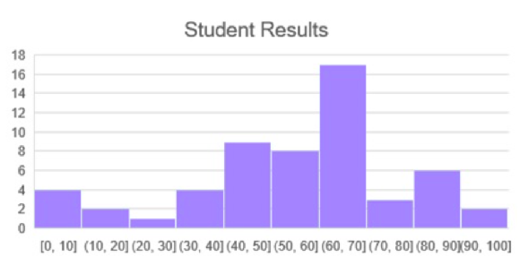

***Ans : Histogram***

1. One approach to handling dirty data is to Fix it. What would this entail?

***Ans : Replace the incorrect value with the correct value***

# Quiz 3 - Types of Data

1. What type of data characteristics is shown in this example:

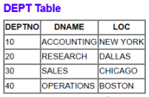

***Ans : Structured data***

1. What type of data characteristics does the following suggest:

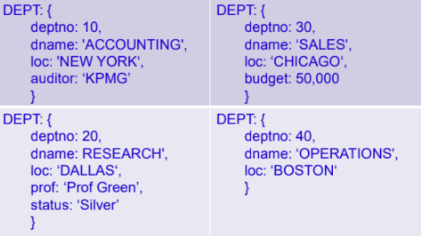

***Ans : Semi-structured data***

1. What does the term NoSQL represent?

***Ans : Not Only SQL***

1. Which of the following is not an example of a type of NoSQL Database?

***Ans : Relational database***

1. Given the following data, what type of NoSQL database would suitable:

| Key | Value |
| --- | --- |
| 10 | {Clark, King, Miller} |
| 20 | {Adams, Ford, Jones, Scott, Smith} |
| 30 | {Allen, Blake, James, Martin, Turner, Ward} |
| 40 |  |

***Ans : Key-value database***

1. Given the following data, what type of NoSQL database would suitable:NoSQL

Structure.

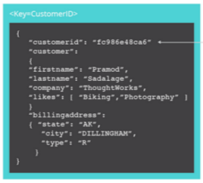

***Ans : Document-based database***

1. Given the following data, what type of NoSQL database would suitable:

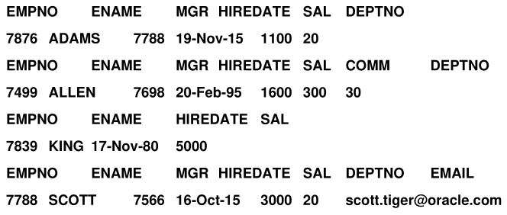

***Ans : Column-family database***

1. Given the following data, what type of NoSQL database would suitable:

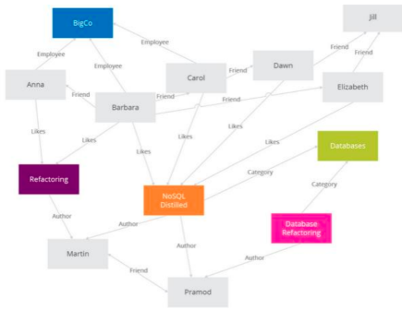

***Ans : Graph-based database***

1. Given a collection called myModules, what would be the MongoDB command to

list all the data in this collection:

***Ans : db.myModules.find()***

1. What type of NoSQL data is MongoDB an example of?

***Ans : Document database***

# Quiz 4 - MongoDB

1. Given a collection called depts that contain all the University’s departments and

has the fields: name, budget and location.

What is the MongoDB command to list the details of the department named

“Maths and Computer Science”:

***Ans : db.depts.find({"name": "Maths and Computer Science"})***

1. Given a collection called depts that contain all the University’s departments and

has the fields: name, budget and location.

What is the MongoDB command that will return all the departments with a budget

greater than £10,000:

***Ans : db.depts.find({"budget": {$gt:10000}})***

1. Using the depts collection, what is the syntax in MongoDB to produce a sum of

the budgets by location:

***Ans :***

***db.depts.aggregate ( [***

***{ $group: { _id: "$location", total: {$sum: "$budget"} } }***

***])***

1. Given a collection called myModules that has the fields: number, name and

credits, what is the command to add a new record for 6CS030:

***Ans :***

***db.myModules.insert({***

***moduleno: "6CS030",***

***name:"Big Data",***

***credits:20}***

***)***

1. MongoDB uses a concept called an Aggregation Pipeline to transform documents

into aggregated results. Which SQL concept is this similar to?

***Ans : GROUP BY***

1. You want to count how many documents there are in the emp collection.

Which command should you use?

***Ans : db.emp.count()***

1. You have a new collection called myTweets which has over 10,000 documents.

You do not know what type of data it contains. Which command can help you find out the structure of a document?

***Ans : db.myTweets.findOne()***

1. What command can be used to find documents containing the word icy in the

weather collection. icy should be found no matter what case it is in (upper, lower,

etc).

***Ans : db.weather.find({text: /icy/i})***

1. What command could be used to find several values in the text field of the

weather collection:

***Ans : db.weather.find({ text: { $in: [/sun/, /rain/, /icy/] }})***

1. What MongoDB command is the equivalent of the SQL query:

SELECT deptno, avg(sal) AS avgSal

FROM emp

GROUP BY deptno

***Ans :***

***db.emp.aggregate ( [***

***{ $group:***

***{ _id: "$deptno", avgSal: {$avg: "$sal"} } }***

***])***

# Quiz 5 - Hadoop

1. Which architecture is best for a Big Data application:

***Ans : Distributed file system***

1. What is a Commodity Cluster with respect to Big Data?

***Ans : A collection of computing nodes connected over a network***

1. What animal is not related to any part of the basic Hadoop Stack ‘Zoo’?

***Ans : Horse***

1. What does HDFS stand for?

***Ans : Hadoop Distributed File System***

1. Name the high level language that is a main part of Apache Pig

***Ans : Pig Latin***

1. Which of the following is not a valid command to handle data in HDFS?

***Ans : cp -r /user/data /user/test/***

1. What is the organizing data structure for map/reduce programs?

***Ans : A list of identification keys and some value associated with that identifier***

1. In the Word Count examples, in terms of key/values, what is the key?

***Ans : The word itself***

1. Which of the following requirements are needed for programming Big Data:

* Handle fault tolerance
* Access data fast
* Distribution computations to nodes
* All of the answers

***Ans : All of the answers***

# Quiz 6 - Hadoop Zoo

1. In Spark transformations are lazily evaluated. What does this mean?

***Ans : The transformation is not executed until an action needs the result***

1. The following is a snippet of Java code from the main method for the Word

Count program:

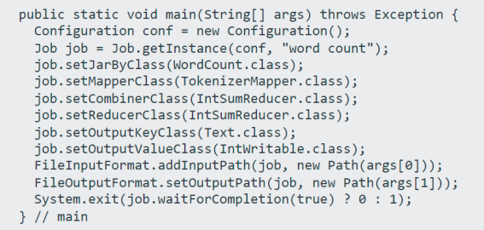

Which line of code tells Hadoop which Mapper class to use?

***Ans : job.setMapperClass(TokenizerMapper.class);***

1. The following is a snippet of Java code from the main method for the Word

Count program:

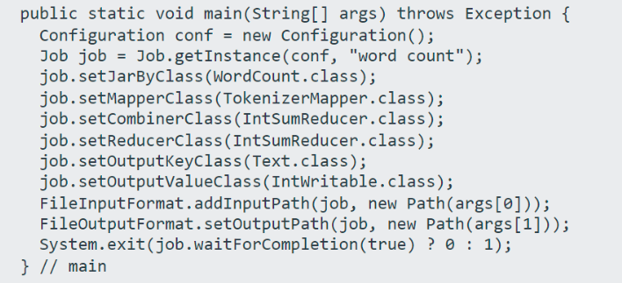

Which line of code tells Hadoop what output directory to create?

***Ans : FileOutputFormat.setOutputPath(job, new Path(args[1]));***

1. Assuming you have a directory called input_dir created in the Hadoop dfs. Which

command allows you to view what files it contains?

***Ans : hdfs dfs -ls input_dir***

1. The following is some example output generated in Spark using the Weather

dataset:

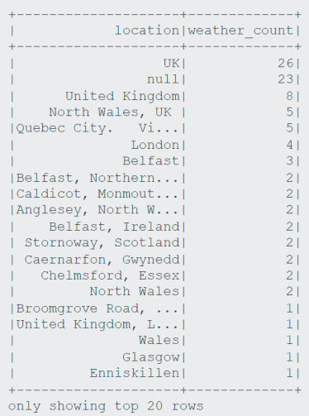

Which of the following commands produced the output above ?

***Ans : spark.sql("SELECT user.location, count(*) as weather_count FROM weather GROUP BY user.location ORDER BY weather_count desc").show()***

1. Using a Spark DataFrame and the Weather json file, which of the following

commands would show just the screen name and name of tweets made by

German users:

***Ans : df.filter(df['user.lang'] == "de").select('user.screen_name', 'user.name').show(40)***

1. What is the order of the three steps to Map Reduce?

***Ans : Map -> Shuffle and Sort -> Reduce***

1. Which of the following Apache Projects can also be viewed as a NoSQL database:

***Ans : HBase***

1. Which of the following can be used to provide Machine Learning in Apache

Spark

***Ans : MLib***

1. Which of the following can be used to analyse a continuous stream of data in

Apache Spark:

***Ans : Spark Streaming***

# Quiz 7 - Consolidation

1. What do you call a computer network where data is stored on more than one

node, which may be replicated?

***Ans : distributed file system***

1. What sort of data is best suited to a bitmap index:

***Ans : Low-cardinality columns such as gender***

1. What is the fundamental unit of data in Apache Spark?

***Ans : RDD***

1. What are two types of operations in Apache Spark?

***Ans : Actions and Transformations***

1. What is a Data Lake?

***Ans : A physical instantiation of a logical Data Warehouse***

1. Which of the following types of applications are more suitable for Big Data

technologies?

***Ans : Massive Grid Computer System such as CERN’s Large Hadron Collider***

***Computing Grid***

1. Which of the following is not a type of NoSQL database?

***Ans : Graphical database***

1. The data in a Data Warehouse is rarely deleted, because the data represents the

company’s history. What stage of Bill Inmon’s famous quote is this an example

of ?

***Ans : Non-volatile***

1. Which of the following types of applications are most suitable for an Online

Transactional Processing (OLTP) system ?

***Ans : Student Information System such as eVision***

1. Is the original data modified during the HDFS lifecycle?

***Ans : No***

# IR Test Quiz - Part 1

1. What is a Crawler (or Spider) for ?

***Ans : A crawler collects Web sites, interacts with Web servers and following links to new web pages to build and update a repository.***

1. What are the 4 steps of indexing in IR, as discussed in the lecture ?

***Ans :***

***Tokenization***

***Stopword elimination***

***Stemming***

***Creation of the inverted index***

1. Which one of the following statements about IR is true ?

***Ans: IR aims at retrieving documents that are relevant with respect to a user’s information need.***

1. How does a crawler (or spider) work ?

***Ans : Starting from a set of seed documents, the crawler follows looks and adds all found documents to the repository.***

1. Below is the (incomplete) software architecture of a (Web) search engine as presented in the lecture. What is the name and purpose of the missing component (with the orange question mark) ?

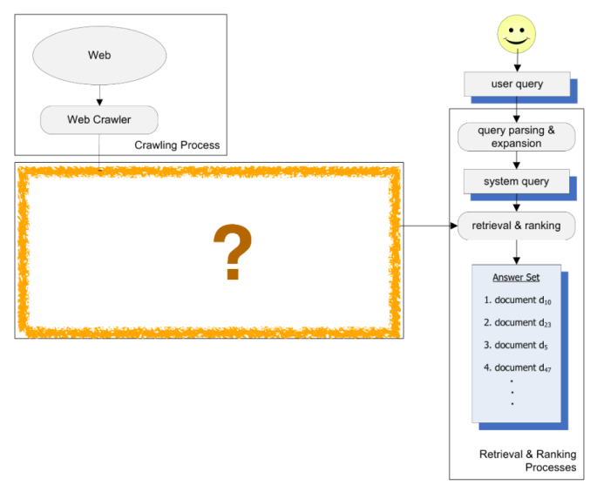

***Ans : Indexing Process - an index processes the document collection (or repository) and creates the inverted index.***

1. What is the basic idea behind the vector space model ?

***Ans : Each query and each document are represented as vectors in a vector space (the term space). Documents are ranked according to decreasing similarity between document and query vectors (the most similar first).***

1. Given the below inverted index, which documents would be retrieved for the query

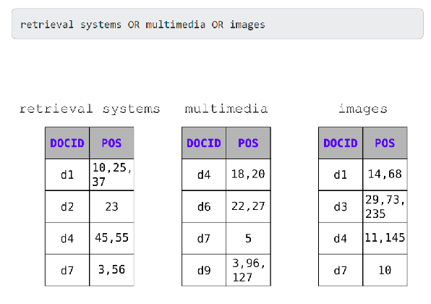

***Ans : d1, d2, d3, d4, d6, d7, d9***

1. What is the purpose of stopword elimination ?

***Ans : Frequent terms like “and”, “or”, don’t bear any meaning for search and retrieval. This means we can eliminate them to keep our vocabulary small.***

1. Consider the following query vector q and document vectors d1 and d2. According to the vector space model, what would be the scores of d1 and d2 and how would the documents be ranked ?

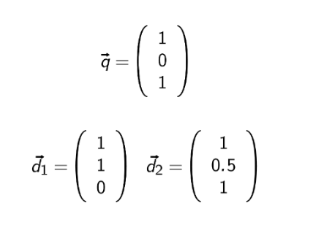

***Ans :***

***1. d2 with score 2***

***2. d1 with score 1***

1. What is one advantage of the PageRank algorithm ?

***Ans : It computes authority values of web pages offline as it doesn’t depend on a query.***

# IR Test Quiz - Part 2

1. Given the below inverted index, which documents would be retrieved for the query

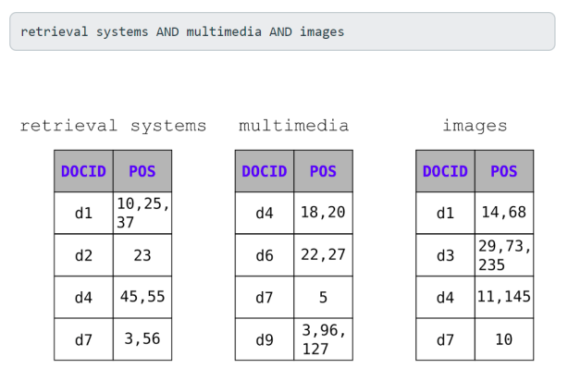

***Ans : d4, d7***

1. Below is the mini toy Web, which of the web pages would you expect to get the highest PageRank ?

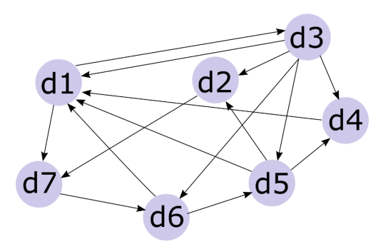

***Ans : d1***

1. What does PageRank calculate ?

***Ans : The authority of a web page.***

1. Consider the following situation in the image below, where we have a query vector q (in red) and 3 document vectors d1, d2, and d3 (in blue). Our toy index consists of the terms ‘cat’ and ‘dog’.

How do you interpret this situation according to the vector space model ? Please choose one correct answer.

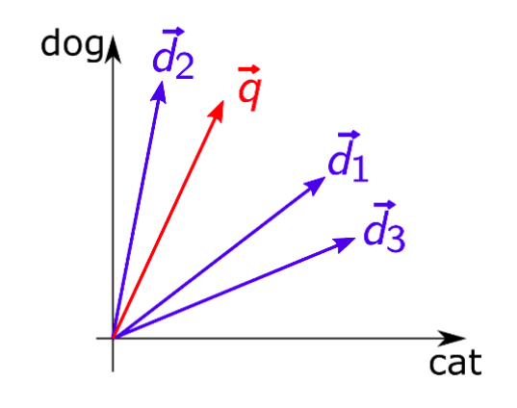

***Ans : d2 is mainly about dogs and only little about cats. d3 is mainly about cats but a bit about dogs, too. The user is interested in documents that are mainly about dogs but would be nice if cats are mentioned, too.***

1. How does the HITS algorithm compute ?

***Ans : Hub and authority values for web pages.***

1. Below is the google architecture as presented in the 1998 Brin and Page paper. What is the name of the missing component (orange question mark) ?

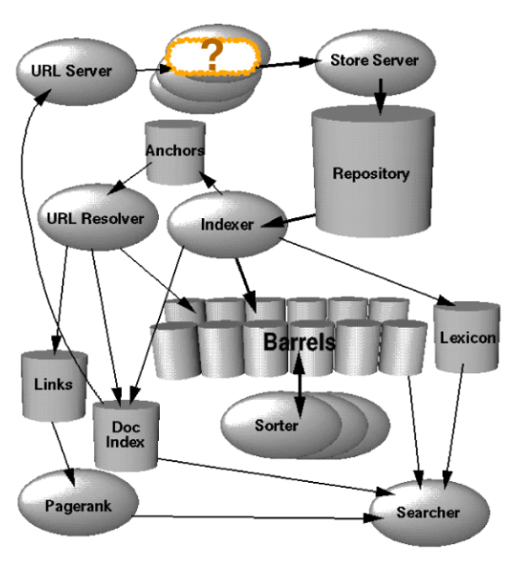

***Ans : Crawler***

# Big Data Quiz

1. What is the purpose of lemmatization in NLP?

* Convert text into numerical format
* Reduce words to their root form
* Remove punctuation marks
* Identify part of speech tags

***Ans : Reduce words to their root form***

1. Which of the following is a common preprocessing step in NLP?

* Compilation
* Garbage Collection
* Tokenization
* Indexing

***Ans : Tokenization***

1. Which of the following techniques is used to convert words into vectors?

* Bag of Words
* Word2Vec
* TF-IDF
* All of the above

***Ans : All of the above***

1. Which scaling method is more fault-tolerant ?

* Vertical Scaling
* Horizontal Scaling
* Both are equally fault-tolerant
* Neither, as fault tolerance depends on backup strategies

***Ans : Horizontal scaling***

1. What does a high positive correlation (close to +1) between two variables indicate?

* One variable increases as the other decreases
* One variable decreases as the other decreases
* One variable increases as the other increases
* No relationship between the variables

***Ans : One variable increases as the other increases***

1. Which Python library is commonly used for EDA?

* Scikit-learn
* TensorFlow
* Matplotlib
* PyTorch

***Ans : Matplotlib***

1. Which of the following is a categorical variable?

* Age
* Blood type
* Height
* Temperature

***Ans : Blood type***

1. Which type of model is used for predicting a continuous numerical value?

* Regression Model
* Classification Model
* Clustering Model
* Reinforcement Model

***Ans : Regression Model***